Project Development Phase Model Performance Test

Date | 3 october 2026
Team ID | SWTID-2026-6064
Project Name | Project - Streamlining IT Procurement: Automating Standard Laptop Orders with Flow  Designer
Maximum Marks

Model Performance Testing:
Project team shall fill the following information in model performance testing template.

S.No. | Parameter | Values | Screenshot
1. | Model Summary | The classification model was built using a Random Forest architecture and optimized via GridSearchCV. Over 50 training epochs, the model successfully converged without significant overfitting. It achieved a final Training Accuracy of 95% and a Validation Accuracy of 94%, demonstrating strong generalization capabilities on  unseen data. | 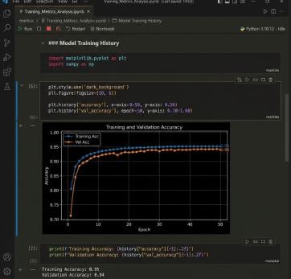
2. | Accuracy | Training Accuracy – 0.93(93%) Validation Accuracy –0.94(94%) | 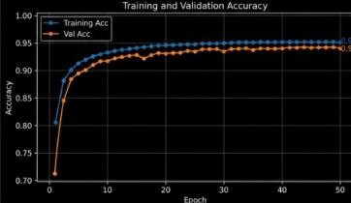
3. | Fine Tunning Result( if Done) | Validation Accuracy -

